**Introduction**

You’re almost there! You can see the Red Planet in its glory. ☄️

But there’s one small problem — you need to know the planet’s rotation before you land. Luckily, you have a dataset of various Mars rotations. Using the ML approach, you can predict the Mars planet rotation!

[Click here to access the starter kit.](http://www.aicrowd.com/showcase/baseline-mars-rotation-prediction)



**💾 Dataset**

The given dataset contains images of Mars's planet from different views. Each image contains its label the angle its is rotated from its axis. The range of angle of rotation is from **1-360.**The dimensions of the images 256*256. The mars planet is only rotated on Z axis!

**📁 Files**

Following files are available in the resources section:

* [train.zip](http://train.zip/) - (40000 samples) This zip file contains the mars planet images with images name corresponding to ImageID column of train.csv
* train.csv - (40000 samples) This csv file contains the ImageID column corresponding to [train.zip](http://train.zip/) and label column as Mars Rotation which is between 0 to 360 degree.
* [val.zip](http://val.zip/) - (4000 samples) This zip file contains the mars planet images with images name corresponding to ImageID column of val.csv
* val.csv - (4000 samples) This csv file contains the ImageID column corresponding to [val.zip](http://val.zip/) and label column as Mars Rotation which is between 0 to 360 degree.
* [test.zip](http://test.zip/) - (10000 samples) This zip file contains the mars planet images which will be used to evaluate the performance of the model.

**🚀 Submission**

* Prepare a CSV containing ImageID column corresponding to [test.zip](http://test.zip/) and label column as Mars Planet Rotation.
* The name of the above file should be submission.csv.
* Sample submission format available at sample_submission.csv in the resources section.

**Make your first submission**[**here**](https://www.aicrowd.com/challenges/mars-rotation/submissions/new)**!!**

**🖊 Evaluation Criteria**

During evaluation [Mean Squared Error](https://scikit-learn.org/stable/modules/generated/sklearn.metrics.mean_squared_error.html) will be used to test the efficiency of the model.

**🔗 Links**

* 💪 Challenge Page: <https://www.aicrowd.com/challenges/ai-blitz-7/problems/mars-rotation>

**Solution**:

The problem is solved using resnet 18 model trained using the mars rotation images and the model is updated to predict among 360 angles as a classification task. The model is trained for 15 epochs with Adam optimizer with Cross entropy loss.

Epoch = 9/10, Val Acc: 98.83, Train Acc: 99.03

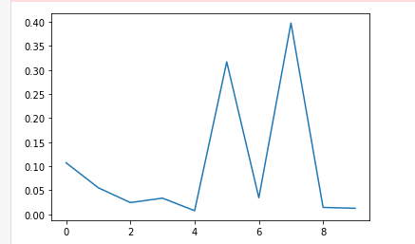

The leader board scores is as below. (MSE = 0.006)

